Welcome Club

January ~ 3:30pm-4:30pm

 Character lesson of the month:

Fairness/Equity -

Listening

* Everyone gets what they need to be successful

**3:30-3:35**

Introduction to Welcome Club  - (Coach Megan)

-Build friendships

-Help each other

-Discuss problems and issues with coaches and students

-Have fun!

 *Review Welcome club’s foundation for how we treat each other: Treat others the way you want to be treated.

-**Transition**- (Coach Megan) “Ok let’s have the coaches introduce themselves and say their favorite part of holiday break!”

**3:35-3:40**

 Introduction of Coaches- We will take turns sharing our name and favorite part of holiday break.

-**Transition**- (Coach Megan) “Ok everyone! Let’s get ready to play a game and meet with coaches in breakout rooms! Everyone grab your Welcome Club bag that was dropped off at your door. If you want to bring some crayons too you can.”

**3:40-3:50**

- Coaches, start your group time by having each student introduce himself or herself. Next, you will need to explain the rules of the game. Assistant coaches are encouraged to participate.

ICEBREAKERS  -Do as I say, not as I do!

Directions:   Head Coach, the goal of the game is for the children to follow the instruction that you say and not follow what actions you are doing. It’s Simon Says but with an extra challenge. Assistant coaches, you can repeat the instruction. Because our students are English learners this could be over their level so support any students you see struggling.

Head Coach, you will need to stand up and give a verbal direction but do a movement that does not match. For example, say, "Clap your hands!" while jumping up and down. The children should clap their hands.

Start with giving 1 direction at a time then as the kids catch on give 2 then 3 directions at a time.

Here is an example of a three-step direction:  
“Jump up and down” (While you spin around)  
“Clap your hands” (While you pat your stomach)  
“Touch your toes” (While you touch your nose)

The correct action would be to jump, clap, and to touch their toes.

Action ideas:

“Jumping jacks” (While you shadow box)

“Scratch your back” (While you scratch your knee)

“Spin around” (While you put hands over ears)

“Stand up” (While you sit down)

“Give me a thumbs up” (While you run in place)

“look through your hands binoculars” (While you pretend to brush or teeth)

“star jumps” (While you pat your head)

“run in place” (While you clap)

“stand still like a statue” (While you spin around)

“touch your head” (While you do jumping jacks)

“pat your head” (While you give a thumbs up)

“rub your belly” (While you look through your hands like binoculars)

“clap” (While you scratch you back)

“pat your back” (While you touch your head)

“dance around” (While you stand like a statue)

**-Transition-** (coaches) “What a silly game to get us practicing our listening! Today we are talking about how listening is a very important part of fairness and equity”.

**3:50-4:10**

 Lesson:    Fairness and Equity-

Coaches:

“Let’s review the definition of fairness/equity. Everyone gets what they need to be successful. And successful means doing and completing a goal. Let’s have an example. If I told you all to write out you name, address, phone number and grade level in English, what would you all need to do that successfully, to complete the goal? You would need a piece of paper, you would need a pen or pencil, and you would need to have know all those things in English too. -------- can you give me an example of equity/fairness? (call on a student for an example.) Great!

You might be thinking, “What does listening have to do with being fair”? That is a good question. Who can tell me why listening is important in fairness and equity? We must listen to each other so that if someone doesn’t have what they need to be successful we can help them or tell someone who can help them get what they need. In distance learning all the students need some things to be successful. ----------can you tell me some things you need in distance learning to be successful?

**Transition**- “I have another listening challenge for you. So you need to listen to what I’m saying and the directions I give you. Get out your stickers and 2021 New Year picture.”

**4:10-4:30 Craft**

**Jellyfish bracelets** [**https://thecraftingchicks.com/jellyfish-friendship-bracelets/**](https://thecraftingchicks.com/jellyfish-friendship-bracelets/)

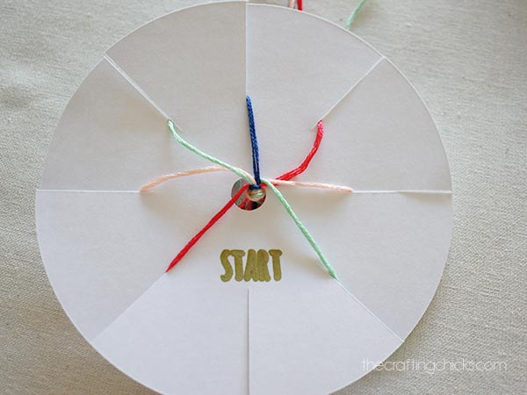

* Video tutorial: <https://drive.google.com/file/d/1jzJHZY-u59ALaaL4fiqUaVzSQGRe1LAX/view?usp=sharing>
* Cut a piece of card stock or thin card boar into a 4 inch circle. Cut 8 1 inch slits into the circle. Puncture the center of the circle making a small hole about the size of a hole punch.
* 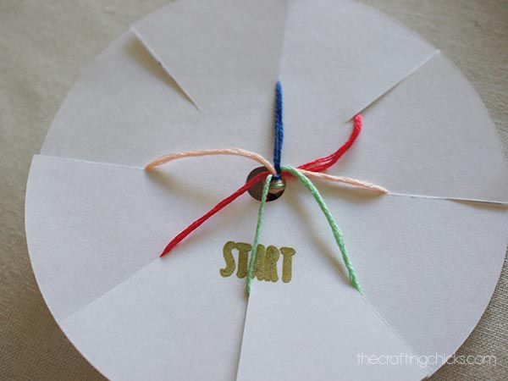Cut 7 strands of embroidery floss about 18inches long. Tie the 7 strands together.
* Put the tied side of the embroidery floss into the center hole of the circle.
* Place 1 strand of Floss in 1 slit in the paper. Repeat until all 7 strands are in a slit. You should have 1 remaining slit with no floss in it.
* Starting from the slit without floss, count 3 strands of floss to the left.
* Move the 3rd strand to the empty slit on the paper.
* 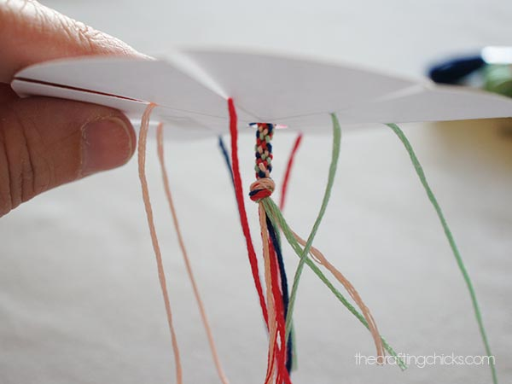Rotate the paper to the new empty slit and count 3 strands to the left again. Move the 3rd strand to the empty slit on the paper.
* Repeat moving the threads 3rd from the left to the empty slit.
* The bracelet will begin to form out the bottom on the center hole.

Conversation starters and fun question ideas-

1. If you could make up a brand new school subject, what would it be?

2. Can you remember a time when you laughed so hard you snorted?

3. Make up a new holiday.

4. What is you favorite letter of the alphabet? Why?

5. If someone gave you $50 dollars what would you do with it?

6. Would you rather eat your least favorite vegetable or have extra homework?

7. When you are sad how do you make yourself feel better?

8. Would you rather pack your lunch or buy from the cafeteria?

9. What is your favorite day of the week?

10.What is the best way to eat an Oreo?

11.What do you normally do during recess?

12. Which state shape do you like the best?

13. Do you have a favorite place in your town?

14. Would you rather scream or whisper?

15. Would you rather take a picture or be in the picture?

16. When you play tic-tac-toe, do you choose to be Xs or Os?

17. When you’re waiting for something, how do you pass the time?

18. What is your favorite chore?

19. If you could do one thing, everyday, for the rest of your life, what would it be?

20. Once you lie down in bed, how long does it take you to fall asleep?

21. If you had a robot for one day what would you ask it to do?

22. What is your favorite thing about yourself?

23. How do you make friends?

24. What’s your favorite thing to do on a snow day?

25. If you could design a zoo, which animal would you have the most of?

**4:30**

 Wrap up and Goodbyes

* Updates and information- (Coach Makayla)
* Tutoring- Thursday 2:30pm  (Coach Megan/Makayla)

**\*Coaches stay on for quick debrief**